Assertion Test in Junit:-
- Follow all the steps to create a file in IntelliJ.
- Once the file is created open pom.xml and add junit dependencies into it.
- To verify them click on the small maven icon on the right side and verify them in the external libraries folder
- Now create a java class file in srctestjava.
- Right click on the javanewjava class. Give a class name to create a java class file named “AssertionsTest”
- Type the given code into the file and add/import dependencies at the beginning.
OUTPUT:
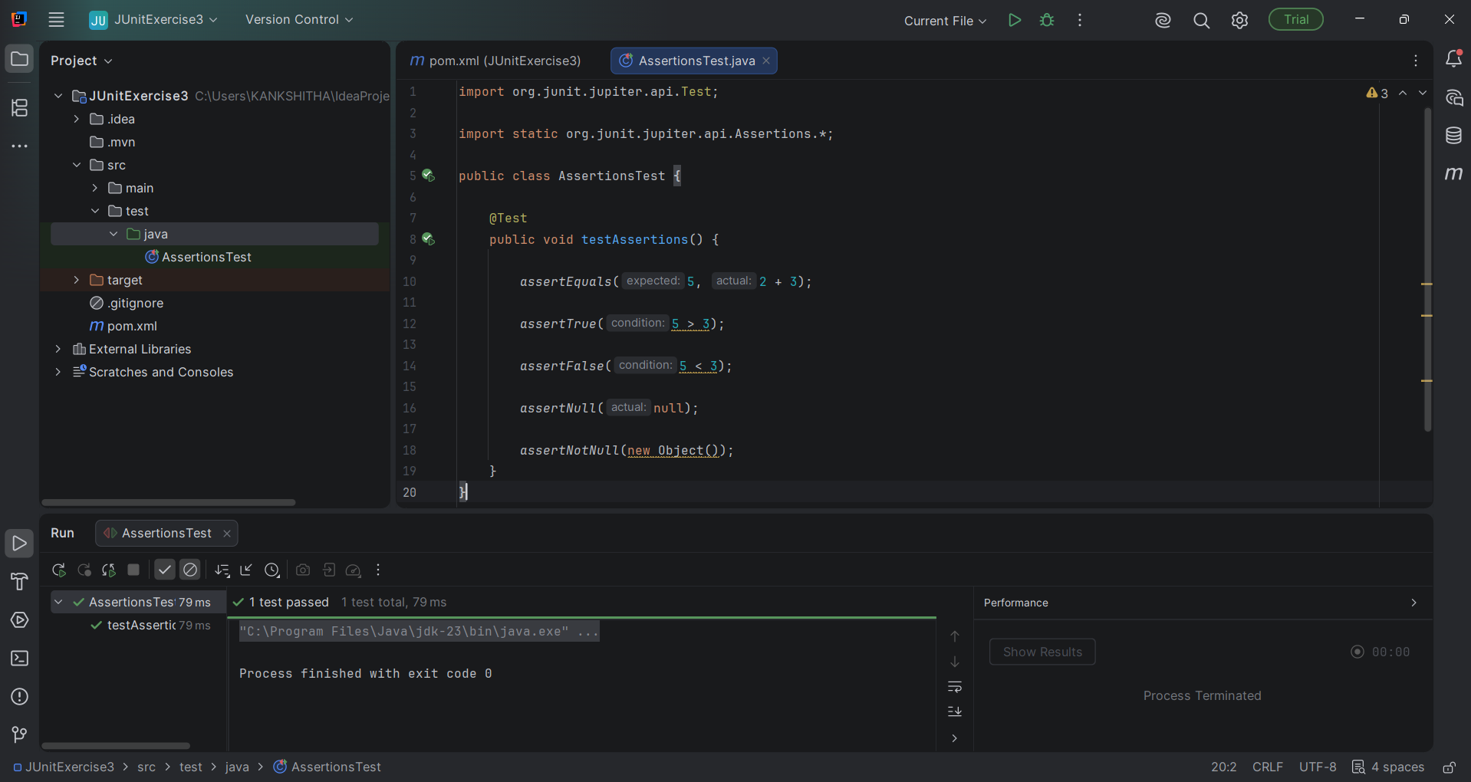
The output that occurs when we run the code is

It shows a green tick, which indicates all the test cases have been passed.

